Face Recognition Attendance System for Employees using Python

- Background/ Problem Statement

The face is the most important part of the human body because it uniquely identifies a person. Face recognition systems can be implemented by using facial characteristics as biometrics. Attendance tracking is the most difficult task in any organization.
Face recognition is a biometric technique that determines whether the image of a person's face matches any of the face images stored in a database.
The primary goal of this project is to build a face recognition-based attendance monitoring system for employees working in an organization in order to improve and upgrade the current attendance system to make it more efficient and effective than before. The employee should be in an area containing light so that the detection can be clearly made.

- Working of the Project

The facial recognition feature embedded in the attendance monitoring system not only ensures accurate attendance but also eliminates flaws. Using a system to overcome defects not only saves resources but also reduces human intervention in the overall process by delegating all complex tasks to the system.
The front-end involves Html, CSS, and JavaScript and the back-end involves Python. The framework used is Django and the database is MySQL. Libraries like OpenCV, Dlib, and Face-Recognition are used here.

- Advantages

- It’s easy to maintain.
- It’s user-friendly.
- No human intervention is required for marking attendance.
- The system recognises faces and records attendance.

- System Description
The system comprises 1 major module with their sub-modules as follows:

EMPLOYEE:
- Register
Details such as name, age, phone number, email address, class password, real-time photo capture, department, course, and class.
- Login
Using username and password
- View Attendance
- Edit Profile
- Logout

- Project Life Cycle

The waterfall model is a classical model used in the system development life cycle to create a system with a linear and sequential approach. It is termed a waterfall because the model develops systematically from one phase to another in a downward fashion. The waterfall approach does not define the process to go back to the previous phase to handle changes in requirements. The waterfall approach is the earliest approach that was used for software development.

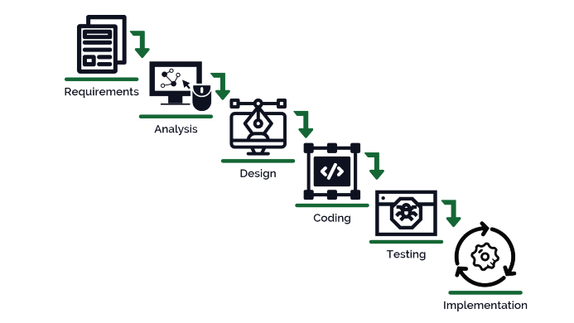

- System Requirements

- Hardware Requirement

- Laptop or PC
- Windows 7 or higher
- I3 processor system or higher
- 4 GB RAM or higher
- 100 GB ROM or higher

- Software Requirement

- Laptop or PC
- Python
- Sublime text Editor
- XAMP Server

- Limitation/Disadvantages
- To detect a face, the candidate must be in an area with light; otherwise, it will not be able to detect it.

- Application – This application is a face recognition-based attendance monitoring system for organisation employees.

- Reference
- https://www.irjet.net/archives/V7/i12/IRJET-V7I12377.pdf
- https://www.questjournals.org/jses/papers/Vol5-issue-2/D05021829.pdf
- https://www.researchgate.net/publication/341870242_Smart_Attendance_System_using_OPENCV_based_on_Facial_Recognition
- https://www.researchgate.net/publication/352393875_Attendance_Management_System_using_Face-Recognition

